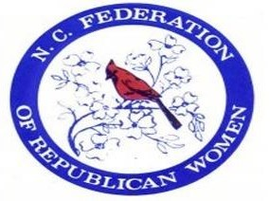

**NCFRW Regents Program**

The NCFRW Regents Program enables us to keep dues low, recruit members, fund special events, train and recruit women candidates and educate voters. Each year, our Regents are recognized at NCFRW events, in our newsletter and on our website.

**GOLD LEVEL: $500* Year 1**: NCFRW Regents pin, NCFRW Regent bag, 1st Year Gold Gift;

**All Following Years**: Gold Gift

**SILVER LEVEL: $250* Year 1:** NCFRW Regents pin, NCFRW Regent bag, 1st Year Silver Gift; **All Following Years:** Silver Gift

**BRONZE LEVEL: $150\***  **Year 1:** NCFRW Regents pin, 1st Year Bronze Gift;

**All Following Years:** Bronze Gift

* Regents payments may be made in installments by check or credit card online.

Thank you,

NCFRW Regents Co-Chairs,

Celeste Stanley & Debbie Dennis

To become a new NCFRW Regent, provide the following information and email or USPS mail to

one of the addresses below (returning Regents do not need to complete the form):

Name: ___________________________________________________________

Address: _________________________________________________________

Email: ___________________________________________________________

Phone: ___________________________________________________________

Home Club: _______________________________________________________

Occupation: ______________________ Employer: _______________________

Check One: _____Gold _____Silver ______Bronze

To make payments by credit card, go to the NCFRW website Regents page [**HERE**](https://secure.anedot.com/north-carolina-federation-of-republican-women/ncfrwregents).

For questions or to email this form, send to: [**ncfrwregents@gmail.com**](mailto:ncfrwregents@gmail.com?subject=NCFRW%20Regents%20Program)

To join the Regents program, or to submit a check, mail this form and your check to:

Pam Keller 107 Country Club Road Kings Mountain, NC 28086